Sri Lanka Institute of Information Technology

**Assignment 2**

Dara Warehouse & Business Intelligence

2021

Submitted By:

Bandara P.M.P.C

IT19243818

**Contents**

**Step 1: Data source for the assignment 2**…………….…………………………3

**Step 2: SSAS Cube implementation** ……...………….………………………….7

**Step 3: Demonstration of OLAP operations** ……...………….……………......11

**Step 4: SSRS Reports** ……...………….…………………………………….......15

**Step 1: Data source for the assignment 2**

The selected data source is a collection of transactional data. The link to the source data set is mentioned below:

[**https://www.kaggle.com/rdoume/beerreviews**](https://www.kaggle.com/rdoume/beerreviews)

Modifications were done accordingly to the data set derived from the source . This Dataset reflects Customer reviews on beers in different breweries.

The two main sources are listed below:

* SQL Database .
* One text file – Customer Data.

Also, the below mentioned CSV files were imported to the SQL source database.

* Beer Details.
* Brewery Details.
* Beer Style Details.
* Review Details.

ER Diagram

Above diagram shows the connection between entities

Data Warehouse Design

Snowflake schema is used to design the Datawarehouse design. There is one fact table as transactions and 5 dimensions. Review per Customer was considered as the grain.

Assumptions

* Brewery Dimension is considered as a Slowly changing dimension

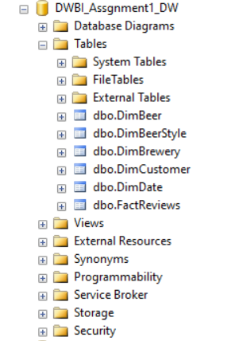I used the Data Warehouse I implemented and loaded with data in Assignment 1 as the source for the Assignment 2.

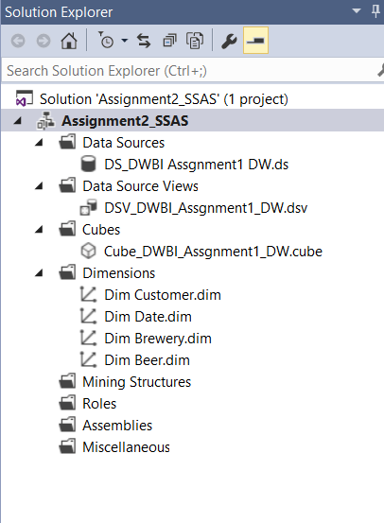**S****tep 2: SSAS Cube implementation**

* 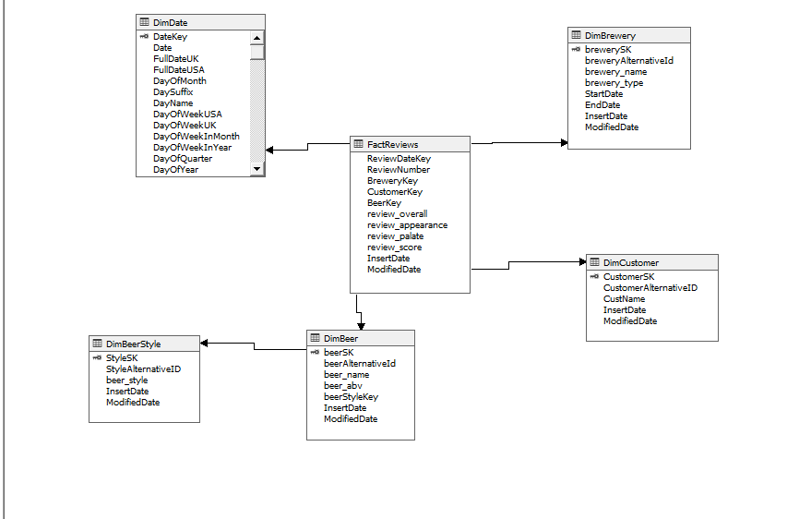First, Created a new Analysis Services Multidimensional and Data Mining project in SSAS. And created a Data Source and a Data Source View as shown below.
* 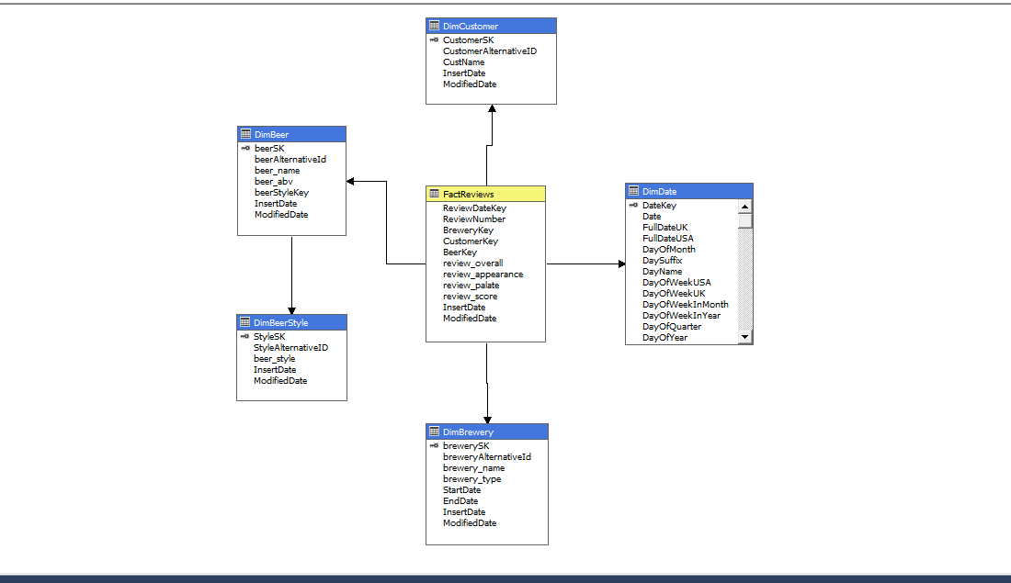Then, Designed the cube including necessary measures in the FactReviews. Also included a hierarchy in DimBrewery and the location hierarchies in DimBeer & 2 hierarchies in DimDate.

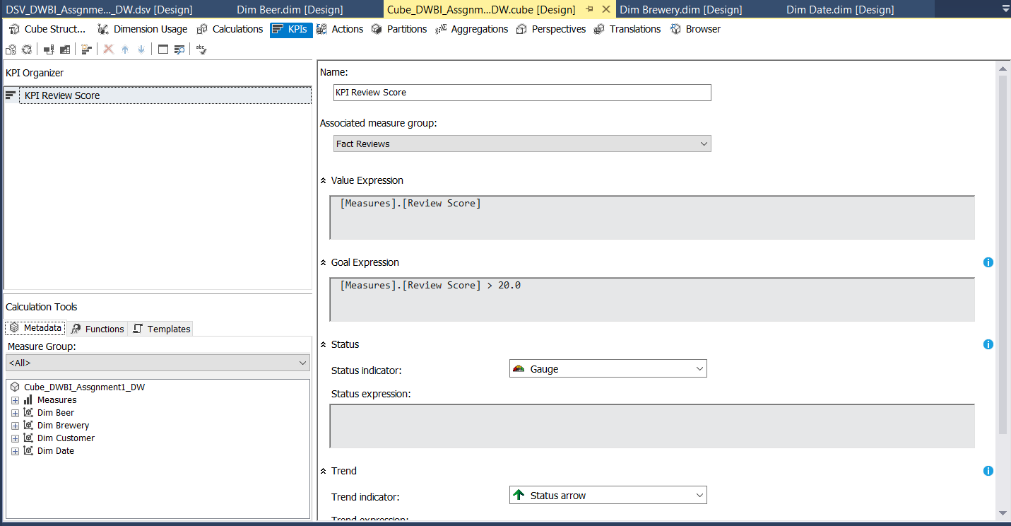To Create cube below KPI is used

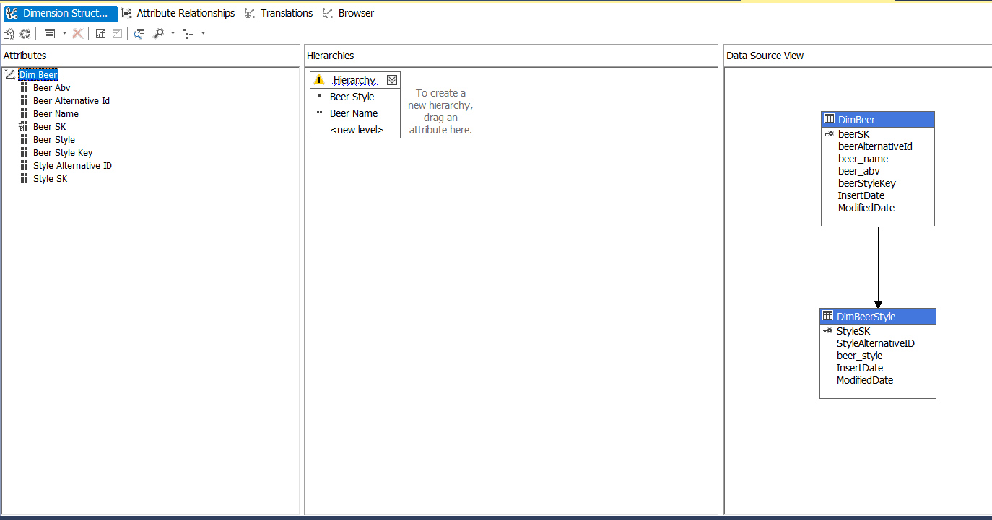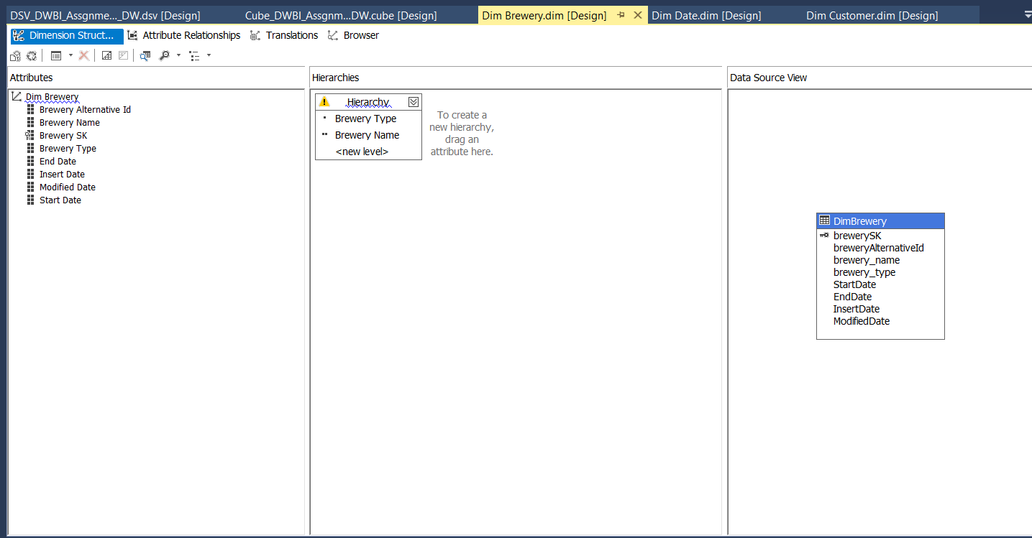Above mentioned hierarchies ,

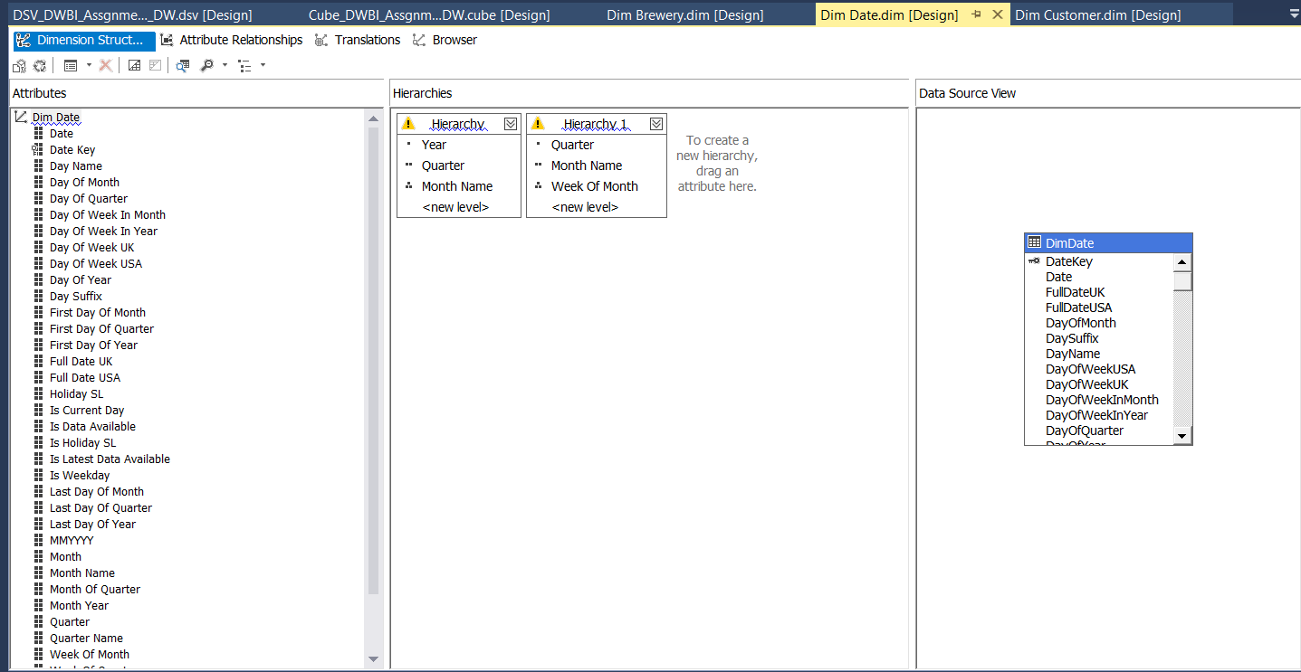

**S****tep 3: Demonstration of OLAP operations**

Connected the excel workbooks to the cube using power pivot & MDX queries and created below operations.

**1.Roll-up**

* 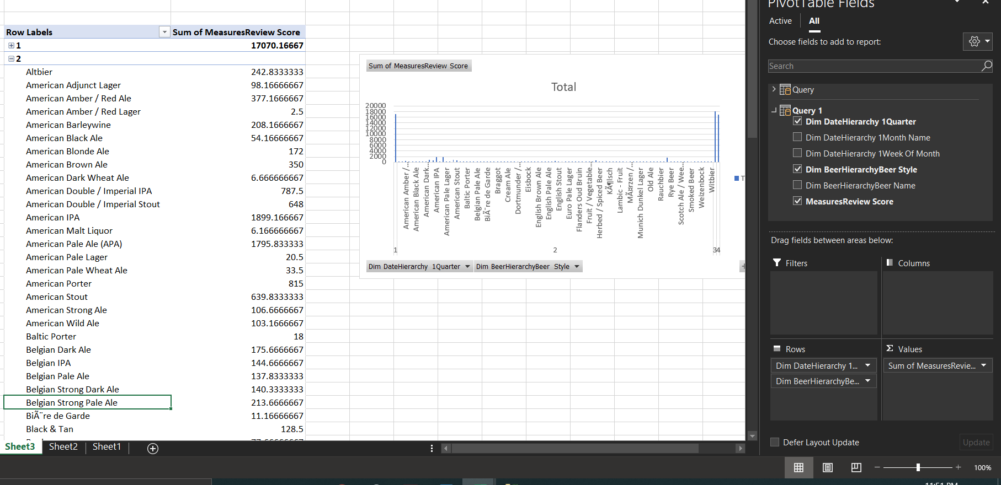Climbing up a hierarchy of a dimension to aggregate data means the Rollup.

* In above sheet shows Review Score details according to the Beer Style (top level of the Beer hierarchy) and the Reviewed year (top level of the date hierarchy)

**2.Drill-down**

* 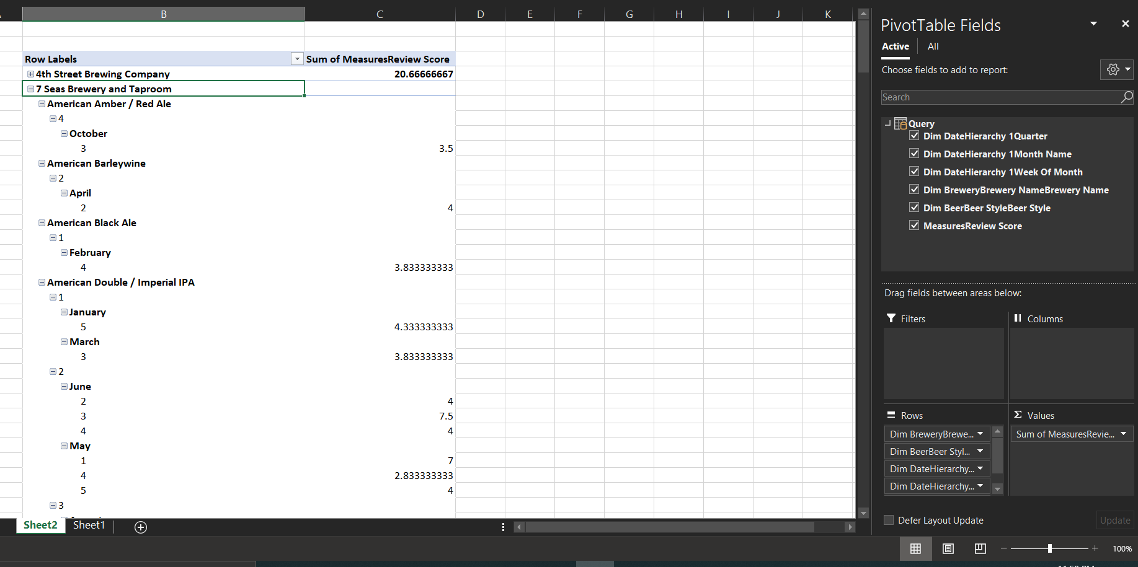Stepping down a hierarchy of a dimension allowing navigation through details means the Drill-down
* In above sheet shows Review Score details according to the Brewery Name and the reviewed date as quarter month and week (hierarchy = quarter → monthname →week).
* Can Drill-down from quater to month name to view Review details

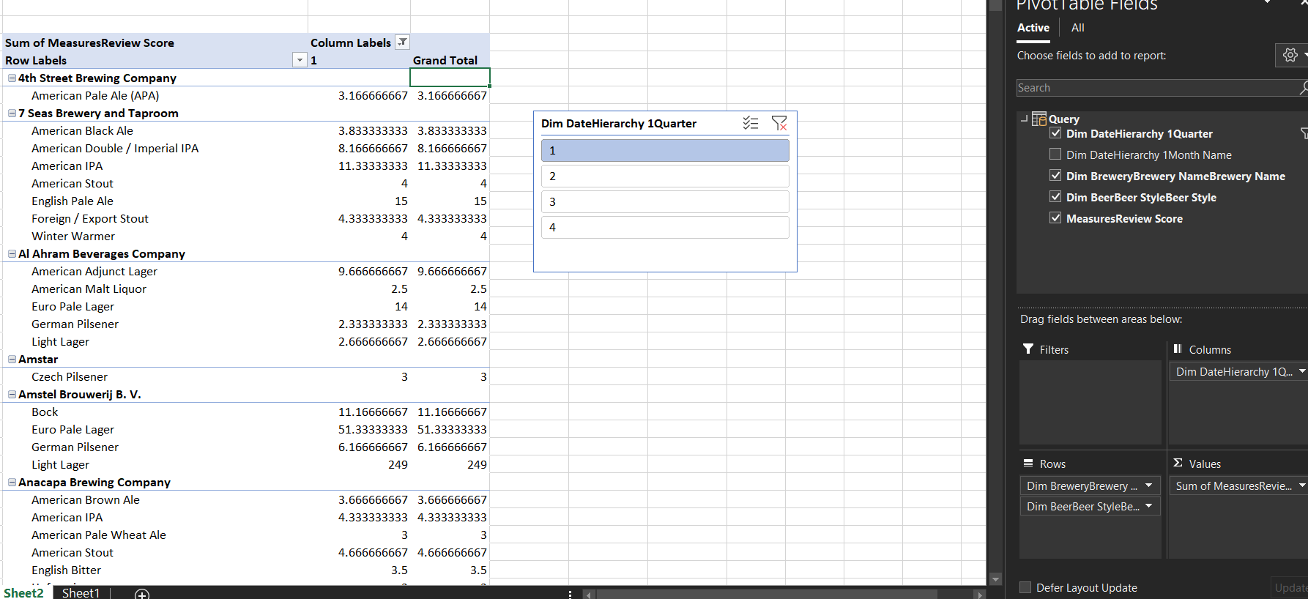**3.Slice**

* This report displays total Review Score details for the Breweries sliced by the Reviewed quarter.

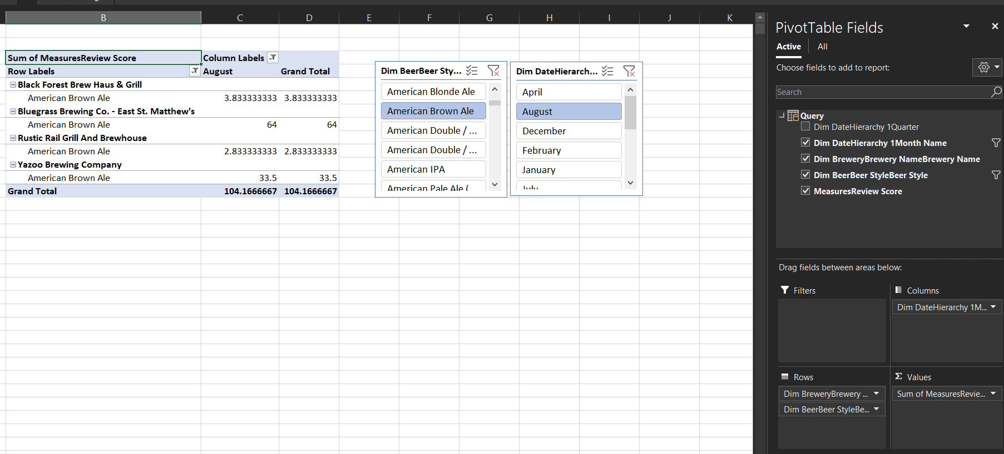**4.Dice**

* This report displays total Review Score details sliced by Beer Style & Reviewed Month.

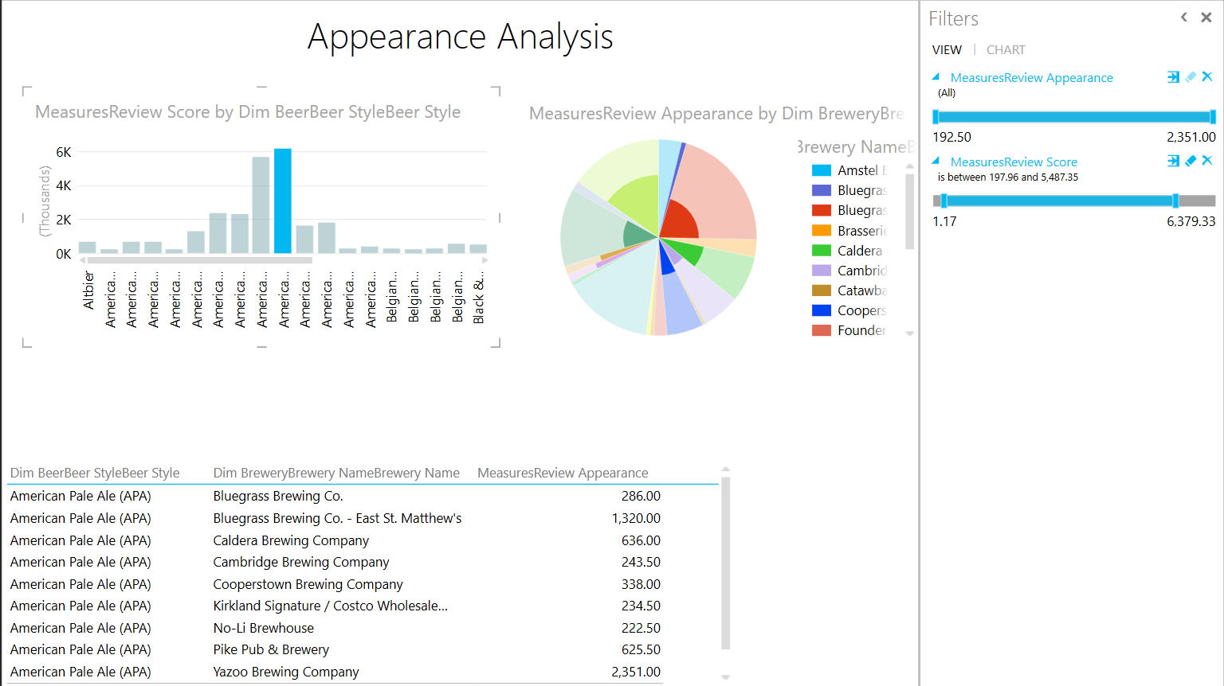**5.Pivot**

* Here we can rotate the data axes to provide a substitute presentation of data.

**Step 4: SSRS Reports**

**Report 1: Report with a matrix**

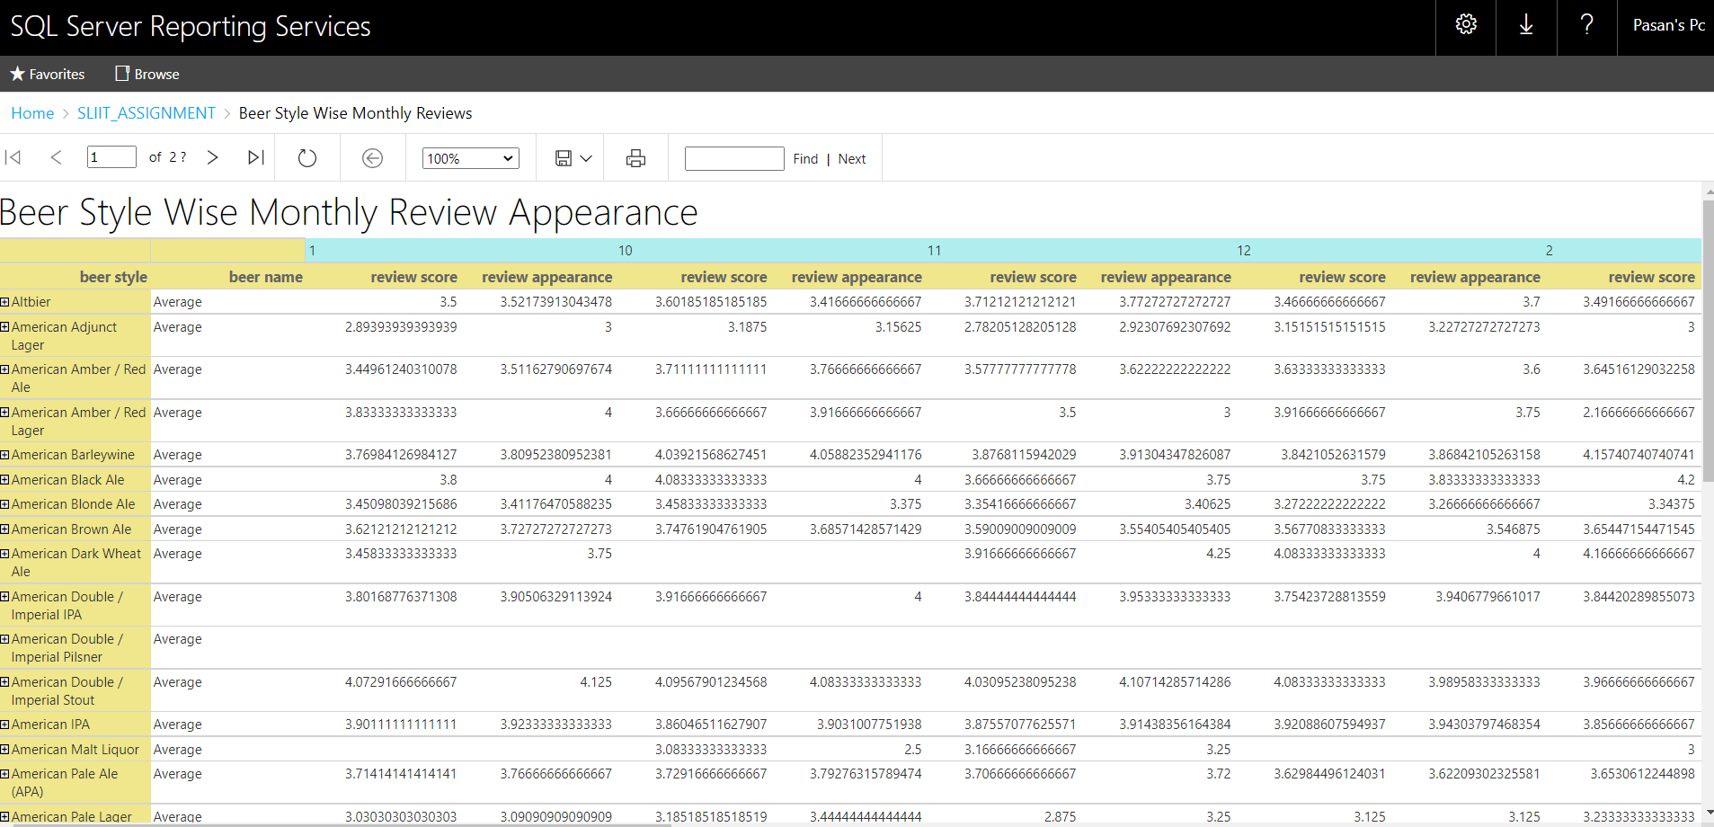

* Here we can see monthly wise Review details in different Beer Styles.

**Report 2: Report with more than one parameter**

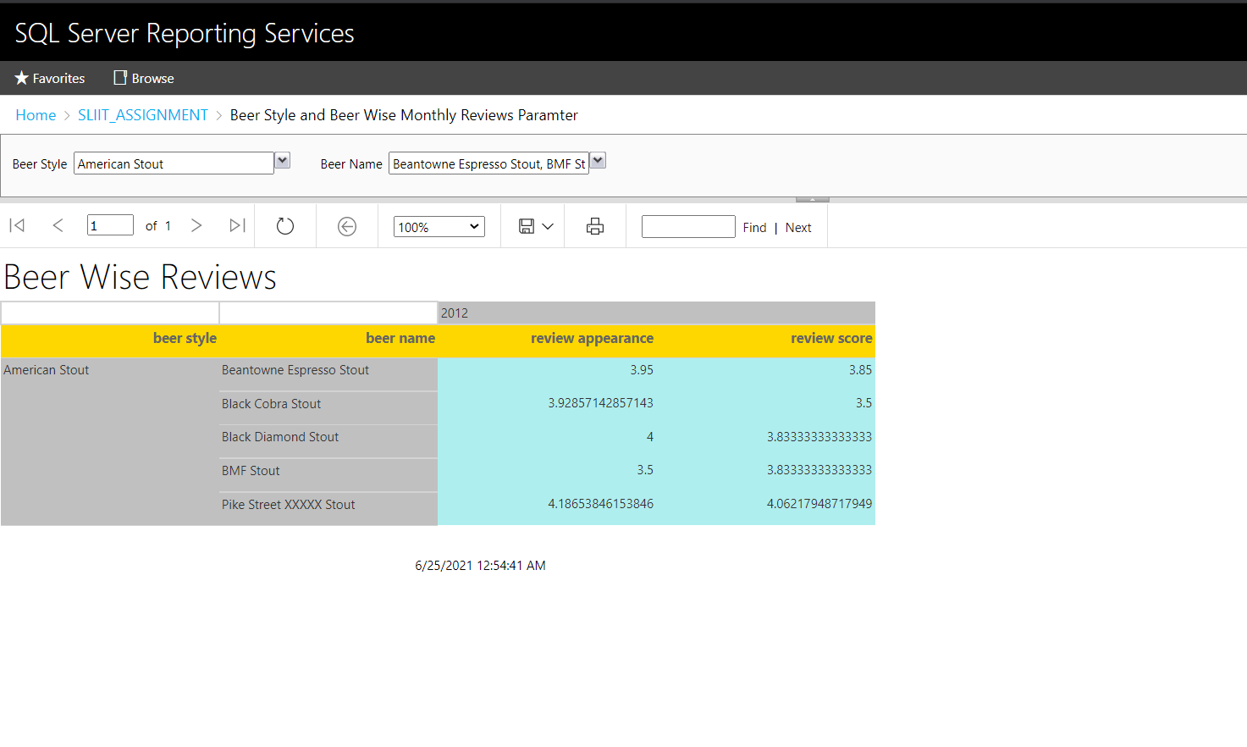

* Here when you select first parameter (Beer Style), Beers are selected which is relevant to that Beer Style. So, the value of the first parameter, will change the list of available values in the second parameter (Beer Name).And multiple beer styles and beer names can be selected.

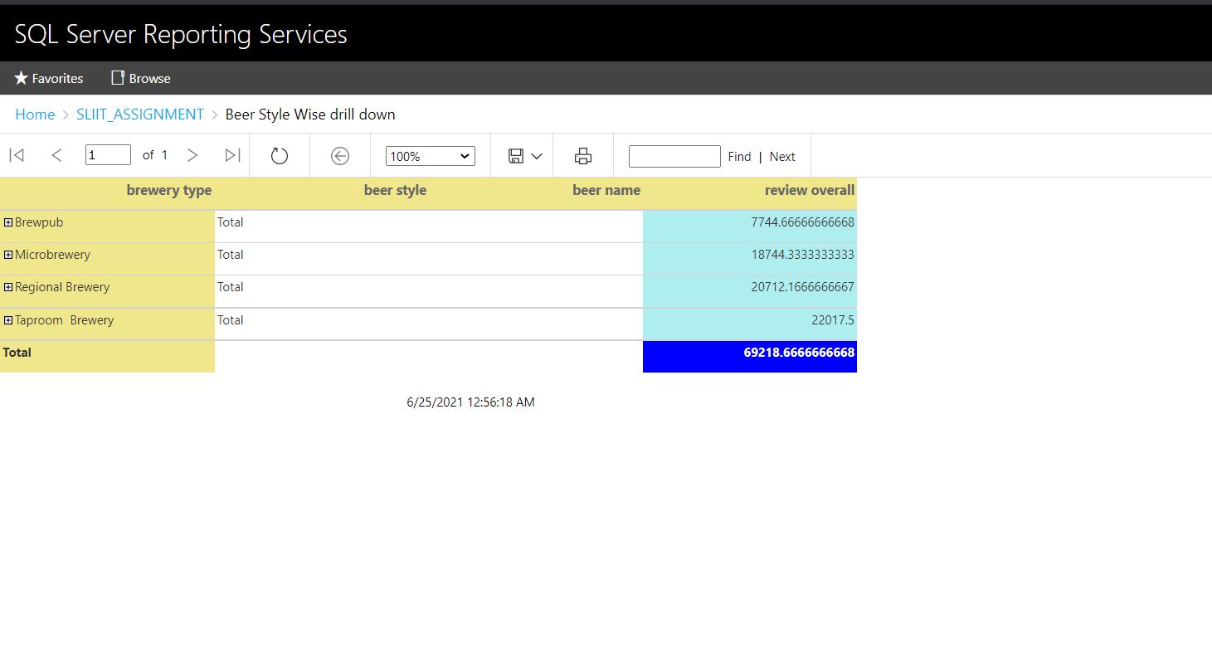**Report 3: SSRS drill-down report**

* Above figure you can view the Brewery Type wise Review overall details and the total of the Review overall.
* 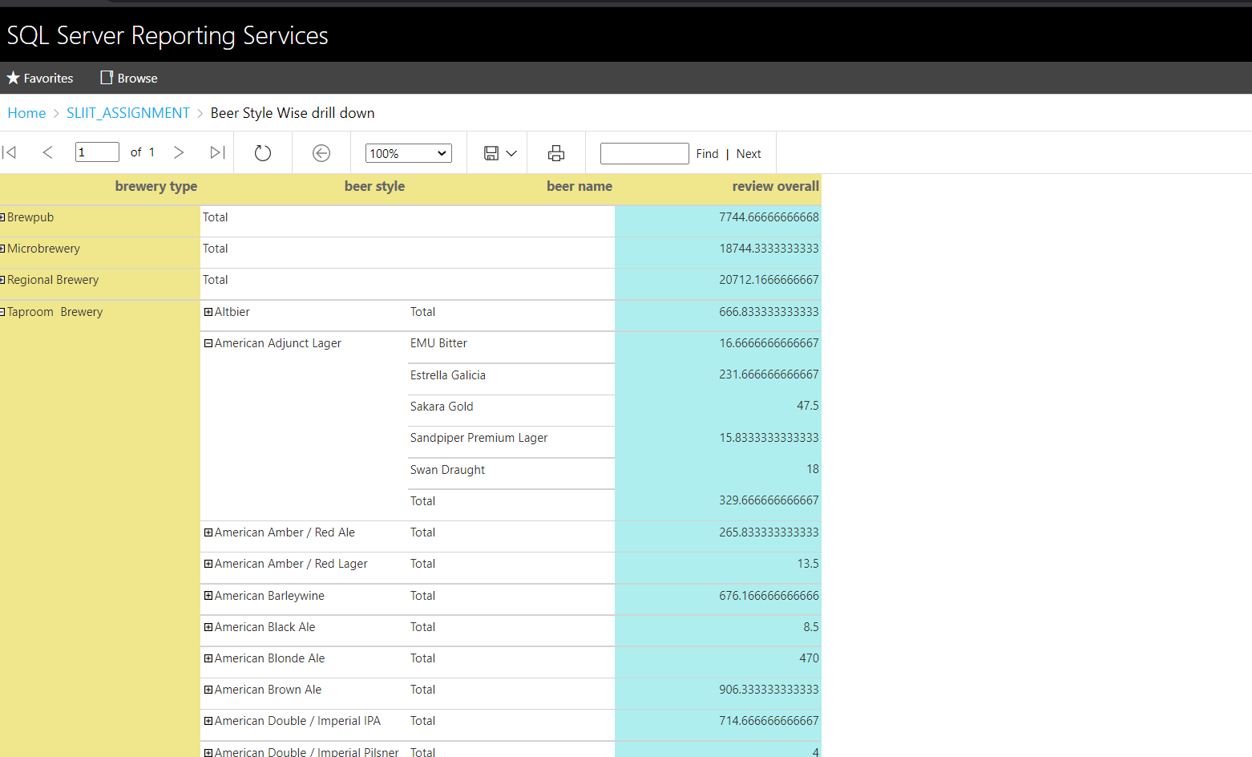Also, you can Drill down from the Brewery Type to Brewery and view the Brewery wise Review overall details like in the below figure

**Report 4: SSRS drill-through report**

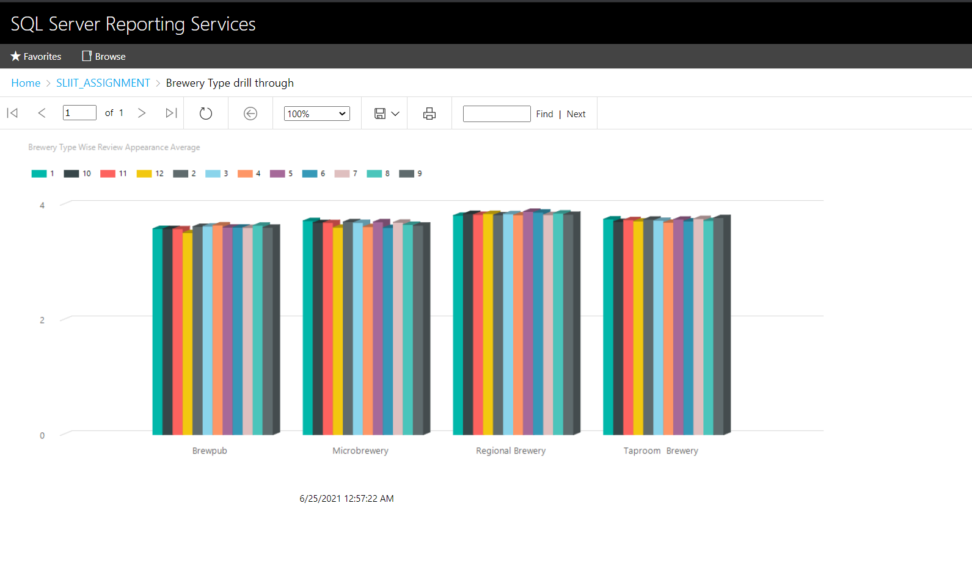

* Above Chart is about the Brewery Type wise Appearance average. When you click a Brewery Type name in the chart, you can drill through to the detailed report as shown in below.
* You can go back to the Summary report by clicking the back button. 